**Mozilla TTS Configuration**

Setup the local environment

Requirements and Installation

Used [miniconda](https://conda.io/miniconda.html) for easier installation.

* python>=3.6
* pytorch>=0.4.1

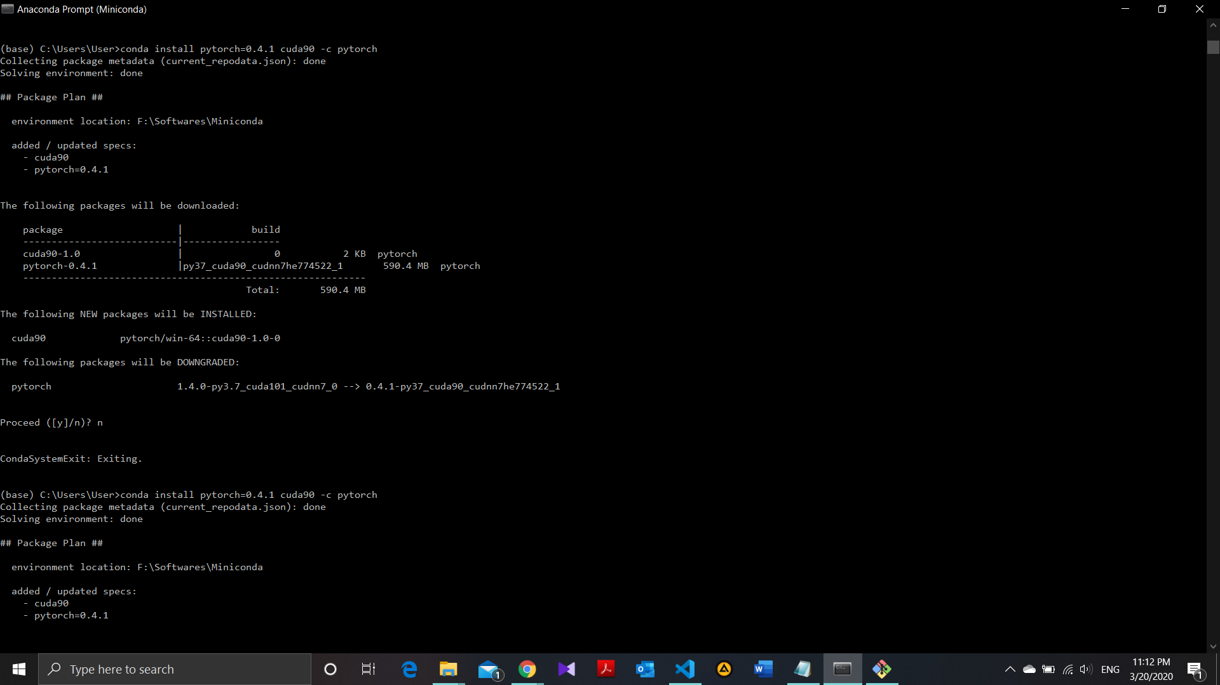

* librosa

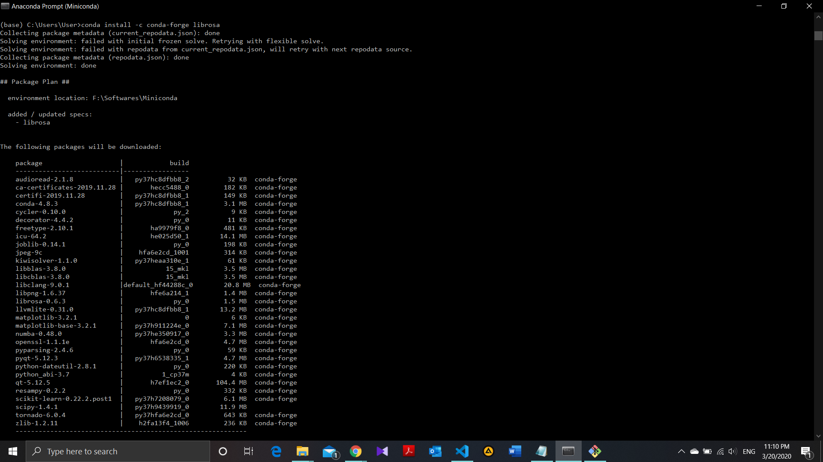

* tensorboard
* tensorboardX
* matplotlib
* unidecode